 ***FACULTY OF ENGINEERING  
  
 FIRST TRIMESTER, SESSION 2018/2019  
   
 ECE2216 – MICRO CONTROL & PROCESS SYSTEM  
  
 ASSIGNMENT (30%)***

***(Measurement System)  
   
 Lecturer: Dr. Tan Wooi Haw***

|  |  |  |  |
| --- | --- | --- | --- |
| ***No.*** | ***STUDENT NAME*** | ***STUDENT ID*** | ***MAJORING*** |
| 1. | ***Adnan Munshi*** | ***1151104799*** | ***LE*** |
| ***2.*** | ***Mohd El Bushra*** | ***1151304755*** | ***EE*** |
| ***3.*** | ***Youssef Yousry*** | ***1161303363*** | ***TE*** |
| ***4.*** | ***Hossam Mohamed*** | ***1161300901*** | ***LE*** |
| ***5.*** | ***Farzana Tabassum*** | ***1161303846*** | ***TE*** |

***Introduction.......................................................................................................................................3***  
  
***Objective.............................................................................................................................................3***  
  
***Description.......................................................................................................................................4-6  
  
Extra Features...................................................................................................................................6  
  
Block Diagram..................................................................................................................................7  
  
Schematic Diagram...........................................................................................................................8  
  
Flowchart...........................................................................................................................................9  
  
Bill Material.................................................................................................................................10-11  
  
Minutes of the Meeting...............................................................................................................12-13  
  
Contribution................................................................................................................................14-19  
  
Conclusion.......................................................................................................................................20***

As the business of online shopping booms, it is imperative that such companies focus on the efficiency they operate with. The quicker they can meet the needs of their customers when it comes to shipping duration and other factors, the higher the customer satisfaction and thus better for the business itself. As larger number of parcels are dispatched day by day, the urgency of being efficient too increases.

One such issue they have is regarding the logistics operation of parcels being shipped. As the measurements of the dimensions are required for a weight/volume-based billing system, an automated system would prove to be vital.

Manually measuring the dimensions of parcels carrying out further calculations would not only prove to be time consuming, but it also carries the factor of human error. Furthermore, for objects that have rather irregular shape, the task of measuring their dimensions could be laborious.

Our group’s objective is to design a prototype of a system that can scan and measure the dimensions of parcels and make further calculations which can not only make the work of a logistics operator easier, but increase the efficiency shipping companies operate with.

To design and develop this prototype, we will be using an 8051 microcontroller. This microcontroller based system will provide us with the required dimensions of the parcel once it’s programmed and other parameters are added for the purpose we are looking to fulfill. The 8051 microcontroller is an 8-bit family of microcontroller.

The system is built around this microcontroller with three ultrasonic sensors. These sensors detect the height, width and length of the given parcel. The signals are then sent to the microcontroller for further processing.

These dimensions will then be displayed in an LCD connected to the system. The microcontroller is programmed to further make the calculations for the volume of the given parcel which is also displayed on the LCD. For this particular prototype, we have used a rectangular box as an object to verify the functionality of the ultrasonic sensors.

***ULTRASONIC SENSOR:***

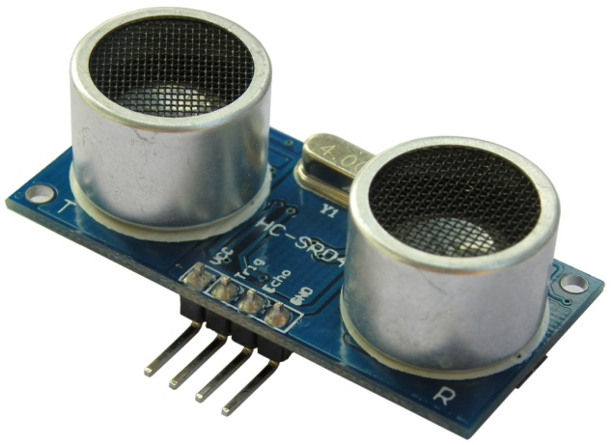

This is an ultrasonic sensor. As the name suggests, ultrasonic sensors measure distance by emitting ultrasonic waves. It emits a high frequency wave and receives the reflected wave from the target. It measures the distance to the target by my measuring the time between emission and reception. The distance is calculated using the following formula :  
 **Distance = $\frac{1}{2}$ ×T × C**

Where T is the time between emission and reception and C is the sonic speed.

The protruding cylindrical shaped parts are responsible for emitting the sound wave and for receiving the reflected wave. Further, we can see the 4 pins which connect it to the system for further integration. They are connected as follows :  
∙ Pin 1 – Connects to VCC.

∙ Pin 2 – Trigger, a pulse is sent here for the sensor to go in to ranging mode for object detection

∙ Pin 3 – Echo, sends a signal back if an object has been detected or not. If a signal is returned, an object has been detected.

∙ Pin 4 – Ground, completes the electrical.

As we need the length, width and height to build this prototype, we will be using three of these ultrasonic sensors which will be placed at different angles.

***LCD:***

For displaying the dimensions as detected by the sensors, we will be using an LCD display. LCD consists of an array of tiny segments (pixels) that can be manipulated to present information. The following is a diagram with the pins of the LCD labeled.

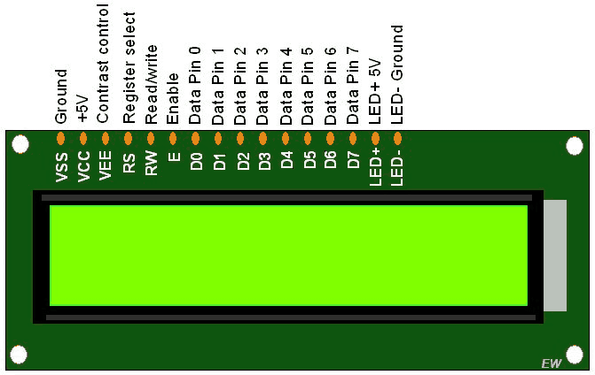

**PIN DESCRIPTION FOR LCD :-**

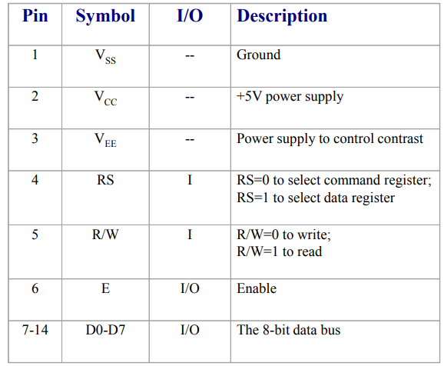

By using assembly language, this LCD display will be integrated to the system of the prototype we are looking to build and will then display the dimensions detected by the ultrasonic sensors.

***SERIAL-TTL CONVERTER (CP2102):***

The CP2102 is a highly-integrated USB-to-UART Bridge Controller. After assembling the hardware and completing the initial programming to make the ultrasonic sensors and the LCD display function, we further carry out to program to get the data from the 8051 microcontroller via serial communication and push the data to an IoT platform. This platform is specialized in connected hardware and software solutions to remotely monitor, control, and automate processes. The platform integrates device management to sensor data brokerage and storage to speed up development.

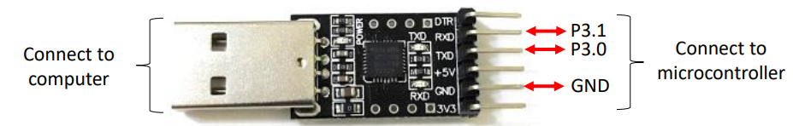

Soldering : Our advanced feature was the use of a PCP board where the parts were soldered on instead of using the breadboard to make it more presentable.

Speaker : Our other special feature was adding a speaker that beeps every time a reading is taken. The idea of this was taken was from our MP2 lab where we had to program certain musical notes to be played through a speaker.

**SERIAL-TTL CONVERTER  
 (CP2102)**

**LCD**

**ULTRASONIC  
 SENSORS**

**µC  
 8051**

**DC ADAPTOR OR BATTERIES**

**POWERBANK**

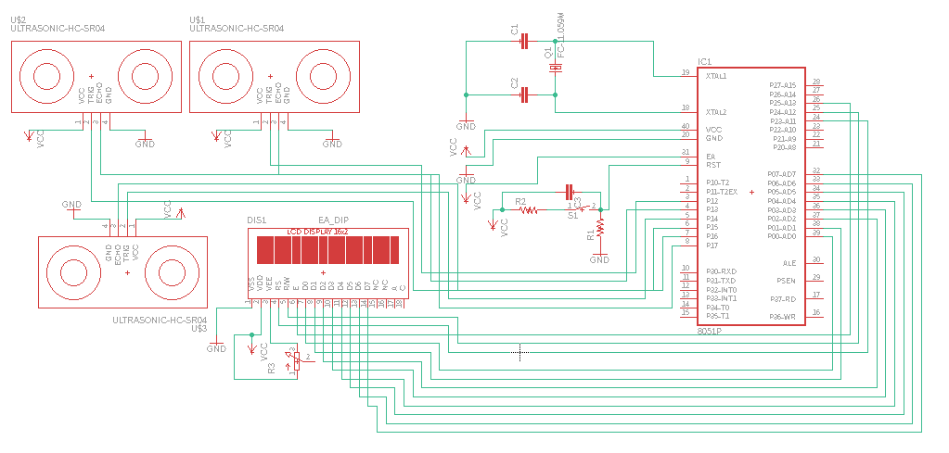



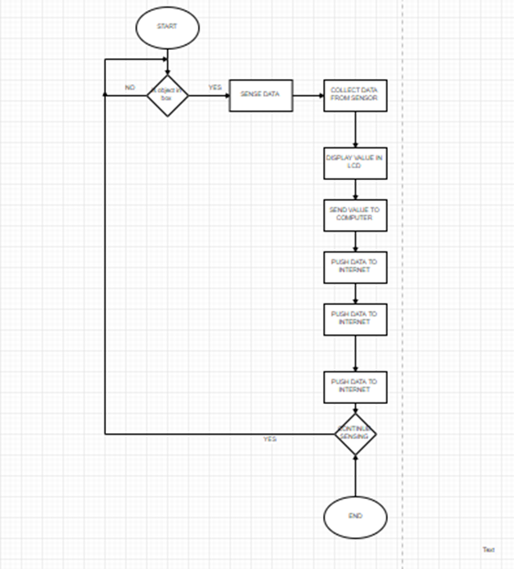

|  |  |  |  |  |
| --- | --- | --- | --- | --- |
| ***No.*** | ***Items’ Description*** | ***Unit Price/RM*** | ***Qty*** | ***Amount/ RM*** |
| 1. | A2 Sandwich Boards | 7.50 | 7 | 52.50 |
| 2. | AT89S51-24PU | 6.50 | 1 | 6.50 |
| 3. | Breadboard | 15.00 | 1 | 15.00 |
| 4. | Capacitor 22pF | 0.20 | 2 | 0.40 |
| 5. | Capacitor 0.1uF | 0.20 | 2 | 0.40 |
| 6. | Capacitor 10uF | 0.20 | 3 | 0.60 |
| 7. | CD-R | 1.20 | 1 | 1.20 |
| 8. | CP2102 USB-TTL UART Converter | 20.00 | 1 | 20.00 |
| 9. | Crystal 11.0592MHz L/P 2Pin | 1.30 | 1 | 1.30 |
| 10. | Cutter | 1.30 | 1 | 1.30 |
| 11. | Duo-digit 7-segment Display  0.56” C.C Red 10Pin | 1.50 | 2 | 3.00 |
| 12. | Hot Glue Gun | 20.00 | 1 | 20.00 |
| 13. | Jumper Wires M to F 20cm | 2.00 | 15 | 30.00 |
| 14. | Jumper Wires M to M 20cm | 2.00 | 40 | 80.00 |
| 15. | LCD (16x2) | 20.00 | 1 | 20.00 |
| 16. | Micro Tact Switch 6mm*4.3mm 4Pin | 0.40 | 1 | 0.40 |
| 17. | PCP | 2.00 | 1 | 2.00 |
| 18. | Potentiometer | 2.00 | 1 | 2.00 |
| 19. | Resistor Array 9Pin 1KΩ | 0.60 | 1 | 0.60 |
| 20. | Resistor 100Ω | 0.20 | 1 | 0.20 |
| 21. | Resistor 8.2KΩ | 0.20 | 1 | 0.20 |
| 22. | Speaker | 10.00 | 1 | 10.00 |
| 23. | Transistor To-92 | 0.50 | 5 | 2.50 |
| 24. | Ultrasonic Sensors  Range: 2cm to 450cm | 9.00 | 3 | 27.00 |
| Total Amount/ RM | | | | 297.10 |

|  |
| --- |
| **MEETING ONEDate:** 23.08.2018  **Time:** 5pm to 6pm  **Place:** Library  **Attendees:** Everyone  **Purpose:** This was our first time having a meeting as a group. At first we all introduced each  other and talked about our strong points regarding the assignment. We then  watched a few videos to get an overview of the subject we will be working on. We  all decided to go home and brainstorm and come up with as many ideas as we can  for our assignment and percolate them in the next meeting. |

|  |
| --- |
| **MEETING TWO Date:** 27.08.2018  **Time:** 6pm to 8pm  **Place:** Foe Classroom  **Attendees:** Everyone  **Purpose:** As decided in the previous meeting, we all shared our ideas and with majority’s  consent we decided on one particular idea. We then dotted down all the   components we will be needing for this particular design and assigned one of our   team members (*Hossam Mohammed, 1161300901*) to buy them. We have also  divided the workload and each one of us were assigned with tasks according to our   preferences.  We made *Mohammed El Bushra, 1151304755* as our team leader. His role was to   make sure we communicate with each other while doing our assigned tasks. He   made sure we did not face any inconvenience while doing our assignment. He was  also part of the coding department along with *Youssef Yousry, 1161303363* and   *Hossam Mohamed Abdelsattar, 1161300901*. We, *Farzana Tabassum,1161303846*   and *Adnan Munshi, 1151104799* dedicated ourselves into the report and making of  video.  However, for the hardware part, we all decided to work on it as a team. |

|  |
| --- |
| **MEETING THREE Date:** 01.09.2018  **Time:** 12pm to 2pm  **Place:** Yousuf’s House  **Attendees:** Everyone  **Purpose:** We have finally purchased our components and started working on the design.  This meeting was to highlight the phases of establishing the circuit and coding.   Further we asked for assistance from each other for any inconvenience caused   while working in any of the subtasks assigned to us. |

|  |
| --- |
| **MEETING FOUR**  **Date:** 06.09.2018  **Time:** 8pm to 9pm  **Place:** FOE classroom  **Attendees:** Everyone  **Purpose:** This meeting was held one day before the interim assessment, focusing solely on  our demo. We for the last time checked all the connections and went through the   whole circuit, analysing and understanding the functions of each component. |

|  |
| --- |
| **MEETING FIVE** **Date:** 16.09.2018  **Time:** 2pm to 4pm  **Place:** Learning Point  **Attendees:** Everyone  **Purpose:** This meeting was called by the coding department of our group, *Yousuf, Hossam*   and *Mohammed* to give finishing touches to the codes and answer our questions   regarding it. We have also implemented the codes into the circuit the very day. |

|  |
| --- |
| **MEETING SIX**  **Date:** 12.09.018  **Time:** 7pm to 11pm  **Place:** Starbucks  **Attendees:** Everyone  **Purpose:** This was our last meeting set to have a final check through the report and the  codes. Also to double check our circuit and make last minute necessary edits to  the video before burning it into the CD. |

|  |  |
| --- | --- |
| **Mohaammed El Bushra** | **1151304755** |

With my fellow team mates’ consent , I was chosen to be the team leader. My foremost job was to make sure we, unitedly, work as a team while gathering as much experience as we can through it. The very first day, through the basic introduction, I tried accumulating the strong points of my group mates and depending on it assigned them to their designated fields.   
  
I have also assisted my team mates in coding. We at first designed a basic code to run our micro-controller. Unfortunately, in our very first attempt we failed to compile the program. That is when I realized that we have not created a separate hex folder using axm for our file. This was indeed a very silly mistake which consumed a lot of our time. That is when I realized how a slight bit of negligence can ruin our whole assignment. Afterwards, we have displayed nothing but sheer dedication while working with the codes.  
  
As decided, we all together worked in designing the circuit. While dealing with the hardware part, I got even more familiarized with each of the circuit components and how they operate with each other to create a system that is both versatile and simple for those who understand.  
  
With the help of the software, eagle, I have constructed the schematic diagram of our circuit. EAGLE stands for Easily Applicable Graphical Layout Editor. It contains a schematic editor, for designing circuit diagrams. Schematics are stored in files with .SCH extension, parts are defined in device libraries with .LBR extension. Parts can be placed on many sheets and connected together through ports. It provides a multi-window graphical user interface and menu system for editing, project management and to customize the interface and design parameters. The system can be controlled via mouse, keyboard hotkeys or by entering specific commands at an embedded command line. Multiple repeating commands can be combined into script files (with file extension .SCR). It is also possible to explore design files utilizing an EAGLE-specific object-oriented programming language (with extension .ULP). Using this, we can avoid complexity and enrich our knowledge in the circuit field.  
  
From this experience, I learned that the simplicity of circuit components allowed for there to be more than only one solution to the common problems that one would face when constructing a system. Furthermore, I learned to use my critical thinking skills in order to solve problems that would seemingly have no solution in the beginning.

|  |  |
| --- | --- |
| **Adnan Munshi** | **1151104799** |

My first job was to write the report. I sat with my fellow coding members and understood each and every coding segment to implement those in the writing. This expanded my knowledge in coding and helped me get a lot of experience in assembly language programming.   
  
I have also worked on the hardware part that includes constructing the circuit. The assembly of the circuit faced many problems in the beginning. Due to the lose connection made by the wires in the circuit, we were unable to load the flash in USB. So we replaced all the loose wirings with jumper wires to make sure the connections were firm. Upon building the original circuit, we found that there were multiple misconnections and several errors in our circuit that we fixed through analysis of the circuit, and later through comparing it with the circuit diagram provided to us.

One of the most important things I have learned in this assignment is the usage of both the hardware and software aspects of microcontroller to build an interactive system that could not only be used in the system that we developed, but also other systems that utilize the same algorithm.  
  
I have also shot the video showcasing the basic and advanced features of our model. Moreover, I made the block diagram with the help of the circuit constructed and along with the group leader worked on building the schematic diagram using the software Eagle.  
  
In this whole assignment, I have browsed the internet a lot that enriched my knowledge in microprocessors and sensors a lot. This was my first time working with LCDs. It was a fun part, even though I faced a lot of hurdles which actually motivated me throughout. And my team also supported and helped me a lot, helping me gain a lot of experience from it. I learned how to relate the assembly code of the microcontroller to the physical circuit at hand, and how to do so not only for this project but for other projects in the future, too. I appreciate the nature of systems design that helped me explore the applications that can be implemented using micro controller.

|  |  |
| --- | --- |
| **Hossam Mohammed Abdelsattar** | **1161300901** |

After dotting down the components that we needed for this assignment, I went to KL and purchased them. Since our meeting was scheduled a few days later, I at first tried constructing a basic circuit at home, experimenting a little with the components. I attended a workshop arranged by IEEE solely based on microcontrollers to give me a head start. There, they gave us all the basic information about the components and helped us work with them.

Since coding was my forte, I decided to work on it. I made a code which can process the basic requirements of the subject including LEDs and ultrasonic with the help of seven segments. Unfortunately after I finished MP2 lab and went through the lab sheets I found many errors in my original code. For example, before modifying the codes, we need to know which port to use, i.e the ports that will allow us multiplexing (which are port 0 and port 1) for both data and address buses.  
  
I have also worked with EDSIM program that allowed me to learn how to measure the frequency and display the measurements detected by the ultrasonic. 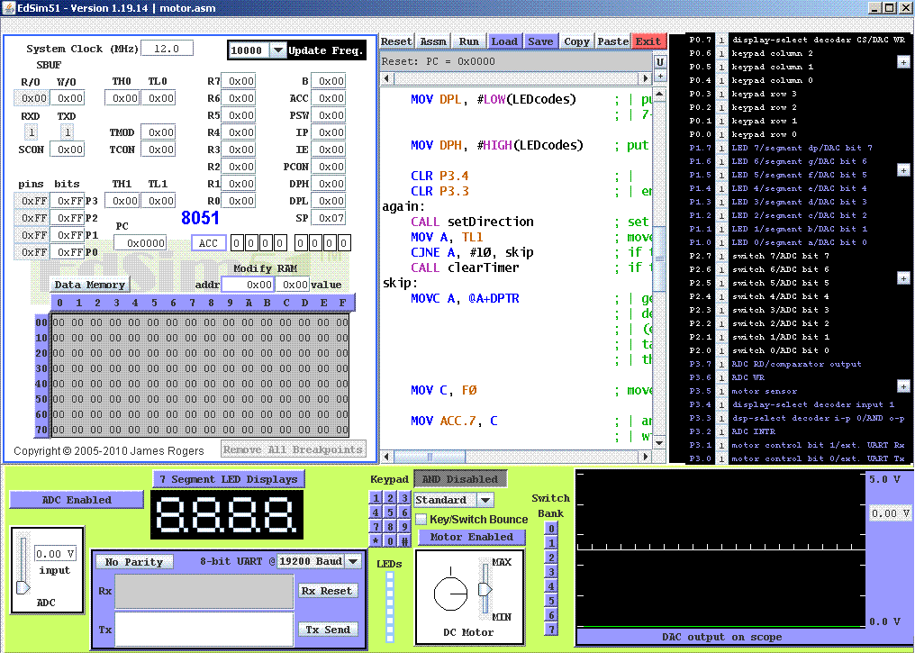

The figure above is a glimpse of how we used EDSIM to get our required outputs. This program helped me check the codes and run them through without obstructing our circuit. However, the problem I particularly faced here is that for some numbers, I had to convert them to ASKI codes as the program is designed to take in ASKI codes only.

The whole journey was very productive as it helped me built my basics and improved my understanding in terms of microcontrollers and their functionalities. I learned how to tackle a technical problem in the right logical order and got utmost co-ordination from my teammates.

|  |  |
| --- | --- |
| **Youssef Yousry Mahmoud Ali Zaghloul** | **1161303363** |

With the help of chapter 3 and 4, I gained the general idea about coding. However, with the help of MP1 and MP2 lab, and assistance from my seniors and internet, I learned how to modify the codes to get the desired output. While doing this, I have faced a lot of problems, since I needed to very carefully select which jmp and resistor to choose to store and to avoid errors. For example, while calculating the volume, I could not use resistor as it takes values upto 1byte only. So I switched to data pointer.  
  
For extra features, we have used soldering. Use of soldering helped us run the circuit in low power. High variety of materials can be joined in it. Furthermore, some pins while used in breadboard do not fit in as they are very small compared to the holes, making it a loose connection. Whereas, use of soldering means no loose connection as we don’t need extra wires to connect. Direct connection with the pins helped us get more accurate values. We have also calculated weight and volume as extra features to the circuit.  
  
Working on this helped me clarify a lot of misconceptions I had towards assembly language as well as developed patience to go through every line of code to debug where I made a mistake. I also see the value of high level languages more clearly compared to low level languages as well as have respect for those who can code in assembly languages for a long period of time without making a lot of mistakes as well as having the patience to correct the mistakes they make in their extremely long codes. I have also learned to co-ordinate and work as a team and work under pressure.

|  |  |
| --- | --- |
| **Farzana Tabassum Fasiha** | **1161303846** |

Assembling circuit has always been a challenging work for me. In this assignment, I found it even more challenging and confusing. However, with the guide of my teammates, I have cleared a lot of concepts regarding it,  
  
Before complying with the instructions given to us, I have tried to run each components separately (ultrasonic sensor and lcd). I have taken help from the slides and the labs I have attended. Even when constructing the basic circuits, I have faced a lot of problems like breadboard failures. After changing numerous breadboards and reconstructing the circuit, I I faced another problem, that is getting ten perfect value for resistor. Along with it, I made sure the resistors are connected to the +ve or –ve terminals directly to minimize the cables power loss. Then I decided to cut the long legs of the resisters in the circuit to make it stick with the bread board body which made the circuit work perfectly.  
  
I have also learned how to send signals from ultrasonic to LCD and how to display the data on LCD detected by the ultrasonic.  
  
I have also helped *Adnan* in editing the report and the video.

After completion of the circuit, I have seen and worked with my teammates to add extra features to it. Though seemingly complex, this process has improved my critical thinking in such a way that I now understand how to incorporate more components into a circuit without disrupting the operation of the original circuit. Overall, through building this system alongside my group mates, I learned how to work as part of the team and to integrate the different types of thinking together in order to achieve a goal. I believe that the team effort in this project is truly what kept us progressing at a steady state where we got to complete all of our tasks on time and to be able to use the brainpower of multiple people to tackle problems that may have otherwise stunted the progress of the project if I had been working alone.

We would like to fully automate our system in the near future by first using a conveyor belt instead of manually placing the parcel we wish to measure. Next we would like to control the belt either through the use of mechanical buttons or by pushing it to the internet as we have with the data sensed by the ultrasonic sensors. Then we would like to add a speaker so that we the user will be able to tell whether there is an item in the box as a sort of error message.